**EXCLUSIVE partnership Catalogue**

**Bars & restaurants**

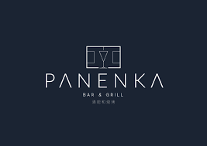

**LOCATION:** Unit 2, & 3, New Era Square, Highfield, Sheffield S2 4RB, United Kingdom

**SERVICE DESCRIPTION:** A stunning premium bar set over two floors with two bars, separate restaurant space with luxury unique VIP Boxes for venue hire. Panenka truly is Sheffield’s Ultimate SocialExperience. Including live sports, and premium gaming experiences

**OFFERS/DISCOUNTS:** 10% off all food and drinks

**fashion**

**a**